Assessment Schedule
Physics: Demonstrate understanding of electrical systems (91526)
Evidence Statement
Achievement | Achievement with Merit | Achievement with Excellence
Demonstrate understanding requires writing statements that typically show an awareness of how simple facets of phenomena, concepts or principles relate to a described situation. For mathematical solutions, relevant concepts will be transparent, methods will be straightforward. | Demonstrate in-depth understanding requires writing statements that will typically give reasons why phenomena, concepts or principles relate to given situations. For mathematical solutions the information may not be directly usable or immediately obvious. | Demonstrate comprehensive understanding requires writing statements that will typically give reasons why phenomena, concepts or principles relate to given situations. Statements will demonstrate understanding of connections between concepts.

Evidence Statement
NØ = No response; no relevant evidence.
Q1 | Not Achieved |  |  | Achievement |  | Achievement with Merit |  | Excellence
(a) | Q = VC = 12 × 125 × 10^{–6} = 1.5 × 10^{–3} C |  |  | - Correct answer 1.5 × 10^{–3} C OR 0.0015 C.
(b) | Resistance is very small, so current is very large.  Resistance is small and the capacitance is also very small./  Time constant is very small  5τ is small. |  |  | - Correct explanation. |  | Some indication to tell that 5τ is small.
(c) | charge (× 10⁻³ C)  time (s ×10⁻³)  16  32  48  64  0.5  1.0  1.5 |  |  | Exponential decay (approx) ignore time axis labels + one of the following:  - decay starts from the value  1.5 × 10⁻³C.  - The line shows 63% drop correctly.  - Time constant = 0.016s calculated. |  | - Achievement plus at least 2 other plots shown from 0.555, 0.2, 0.08, 0.03.  - Time axis should have correct values
(d) | The lamp will be at or above its normal brightness if the voltage across it is at, or above, the voltage of the lamp.  When V = 9.0 V, Q = 9.0 × 125 × 10⁻⁶ = 1.125 × 10⁻³ C  Reading from the graph:  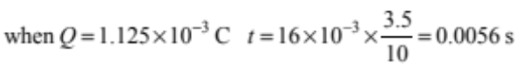 |  |  | - Correct charge calculated  1.125 × 10⁻³ C  OR  - Correct time scale used for part (c) |  | TWO of:  - Correct charge and  - Correct time scale used for part (c)  - If the time axis is incorrect, but time is consequently calculated correctly. |  | Correct Time  Accept .0030 – .0064 s  OR  If the only error is the incorrect time constant used for x-axis scale, but time is consequently calculated correctly  Accept range 0.00004 – 0.00009 s.
(e) | 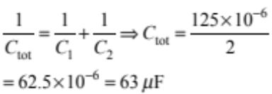 |  |  | - Correct answer.  - Working must be shown.
/mj(f) | The time constant is reduced because the capacitance of the circuit is less (τ = RC). Less charge is stored on the plates of each capacitor (Q = CV). Less charge can flow off the plates of the capacitors more quickly. |  |  | - τ = RC so lower τ because lower C.
Q1 |  | N1 | N2 | A3 | A4 | M5 | M6 | E7 | E8

Q2 | Not Achieved |  |  | Achievement |  | Achievement with Merit |  | Excellence
(a) |  |  |  | - Correct answer 0.737 (J).
(b) |  | 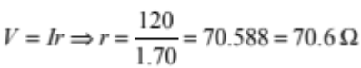  (r ishe internal resistance of the inductor). The maximum current is inversely proportional to r. |  | - Correct value 70.6 Ω.  Correct explanation.
(c) |  | - When the switch is closed the current starts to increase from zero, and so there is increasing flux in the coil.  - The emf induced by the changing flux will oppose the changing current making it take longer to build up to its maximum value. |  | - ONE correct statement.  OR  - Greater the inductance, the longer the time for the current to reach the max value. (T is directly proportional to L  (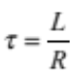 ), |  | - Both correct statements.
(d) |  | Nothing because the gap AB is effectively on open switch so nothing changes. |  | - Nothing. |  | - Nothing.  - Because the gap acts as an open switch / circuit.  Do not accept being in parallel as a reason.
(e) |  | When switch 1 is opened. the current in the circuit will drop to zero and while it is changing a voltage is induced in the inductor. Because there is no longer a battery in the circuit, the induced voltage is no longer limited by the voltage of the battery so the rate of change of current, and hence induced voltage, depends on the time constant of the circuit. As the gap is effectively a huge resistance the time constant is very small so the rate of change of current and hence induced voltage is very high – high enough to produce a spark. |  | - Recognition that the battery is no longer limiting the size of the induced voltage.  OR  - Large induced voltage across inductor linked to change in current when switch 1 is opened.  OR  - Current dies very quickly .  OR  - Energy stored in the inductor is released. |  | - Large induced voltage across inductor linked to rapid change in current when switch 1 is opened.  AND  - Due to very short time (constant).  OR  - The Kirchoff’s law does not apply due to swtich being open.  OR  - The Induced voltage can exceed the battery voltage due to the open switch. |  | - Explanation shows complete understanding that opening the switch will produce a very high induced voltage because the rate of change of current will be very high.  - because the time constant will be very small.  - because the resistance will be very big.
Q2 |  | N1 | N2 | A3 | A4 | M5 | M6 | E7 | E8
 |  | ONE point | TWO point | THREE points | FOUR points | 1m + 3a | 2m + 2a | 1e + 1m + 2a | 1e + 2m + 1a

Q3 | Not Achieved |  | Achievement |  | Achievement with Merit |  | Excellence
(a) | 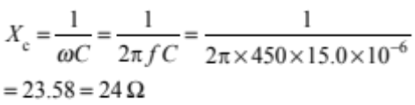 |  | - Correct answer.
(b) | The current is in phase with the resistance and the supply voltage is in phase with the impedance.  55 Ω  93 Ω  θ  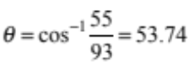  Current lags the supply voltage by 54° or 0.94 rad. |  | - Recognition that voltage phase difference is the same as impedance phase difference.  OR  - θ is labelled correctly in the diagram |  | - Correct answer. 54° or 0.89 rad
(c) | 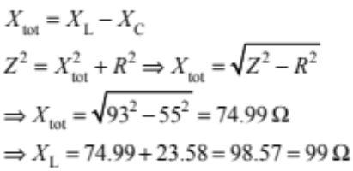 |  | - Correct X_{tot}. 75Ω  OR  - If the value of XL is substituted as 98.6 and then te Z is calculated as 93 Ω. |  | - Correct answer 99 Ω.
(d) | To bring the circuit to resonance, the frequency must be changed to make the two reactances equal in value. X_{L} is directly proportional to f and X_{C} is inversely proportional to f so changing the frequency will increase one but decrease the other. X_{L} > X_{C} and so to decrease X_{L} and increase X_{C}, frequency must be decreased. |  | - Recognition that the frequency has to be decreased to make the X_{c} = X_{L}.  OR  - Recognition that the frequency has to be decreased, as by decreasing f, the X_{L} decreases and X_{C} increases. |  | Achievement +  - By decreasing f, the X_{L} decreases and X_{C} increases.
(e) | 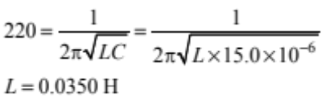 |  | - Correct answer. 0.0350H.
(f) | When the circuit is in resonance, the current is greatest because the reactance is zero and so the impedance is smallest. When the current is greatest the sound from the speaker is loudest. The current decreases rapidly either side of resonance because the reactance increases either side of resonance. So if the frequency is reduced quickly through the resonant frequency and down below it, there will be a brief surge of current and so a brief burst of sound. |  | - Recognition that the max sound happens at resonance.  OR  - Recognition that the frequency must be changed down through the resonant frequency.  OR  - Current-frequency diagram. |  | - Achievement.  AND  - Maximum current at resonance explained. |  | - Full explanation linking greatest sound to maximum current and zero reactance / impedance = R at resonance Rapid decline in current either side of resonance requires bringing the frequency quickly through the resonant frequency.
Q3 | N1 | N2 | A3 | A4 | M5 | M6 | E7 | E8
Q3 | ONE point | TWO points | THREE points | FOUR points | 1m + 3a | 2m + 2a | 1e + 1m + 2a | 1e + 2m + 1a

Judgement Statement
 | Not Achieved | Achievement | Achievement with Merit | Achievement with Excellence
Score range | 0 – 6 | 7 – 13 | 14 – 18 | 19 – 24

